OBJECT ORIENTED PROGRAMMING USING PYTHON LAB FILE

Manav Rachna International Institute of Research and Studies

School of Computer Applications

Department of Computer Applications

Submitted By
Student Name | Abhinav Mishra
Roll No | 24/SCA/BCA(AI&ML)/002
Programme | BCA (AI&ML)
Semester | ³
Section/Group | C
Department | School of Computer Applications
Session / Batch | 2024-27
Submitted To
Faculty Name | Dr Sakshi Gupta

 | SCHOOL OF COMPUTER APPLICATIONS

1. Calculate number of days between two dates
Code - from datetime import date

# Take input from user
y1, m1, d1 = map(int, input("Enter first date (YYYY MM DD): ").split())
y2, m2, d2 = map(int, input("Enter second date (YYYY MM DD): ").split())

# Create date objects
date1 = date(y1, m1, d1)
date2 = date(y2, m2, d2)
print(f"Number of days between: {delta.days} days")

# Difference
delta = abs(date2 - date1)

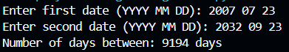

2. Write a Python program that accepts an integer (n) and computes the value of n+nn+nnn
Code - n = int(input("Enter an integer: "))
result = n + int(str(n)*2) + int(str(n)*3)
print("Result:", result)

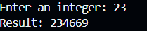

3. Ask the user for a number. Depending on whether the number is even or odd, print out an appropriate message to the user. Hint: how does an even / odd number react differently when divided by 2?
Code - num = int(input("Enter a number: "))

if num % 2 == 0:
print("Even number")
else:
print("Odd number")

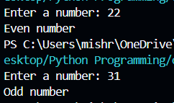

4. Write a Python program which accepts a sequence of comma-separated numbers from user and generate a list and a tuple with those numbers.
values = input("Enter comma-separated numbers: ")

# Split into list
list_values = values.split(",")

# Convert to tuple
tuple_values = tuple(list_values)

print("List:", list_values)
print("Tuple:", tuple_values)
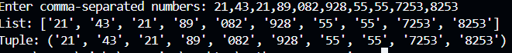

5. Write a Python program to calculate the sum of three given numbers, if the values are equal then return thrice of their sum.
Code - def sum_three(a, b, c):
total = a + b + c
if a == b == c:
return total * 3
return total

# Taking input from user
a, b, c = map(int, input("Enter three numbers separated by space: ").split())

# Calling function and printing result
print("Result:", sum_three(a, b, c))

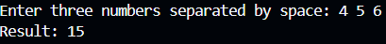

6. Write a Python program to test whether a passed letter is a vowel or not
Code- letter = input("Enter a letter: ").lower()

if letter in 'aeiou':
print(f"{letter} is a vowel")
else:
print(f"{letter} is not a vowel")

